WHOIS Enumeration?
WHOIS enumeration is the process of gathering domain registration information about a target using WHOIS databases. It’s an important part of information gathering (recon) in ethical hacking or penetration testing.
Whois hackersploit.org
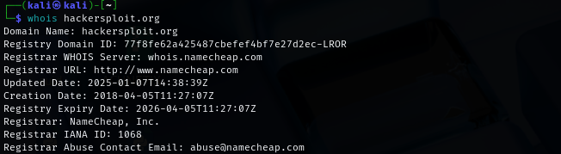
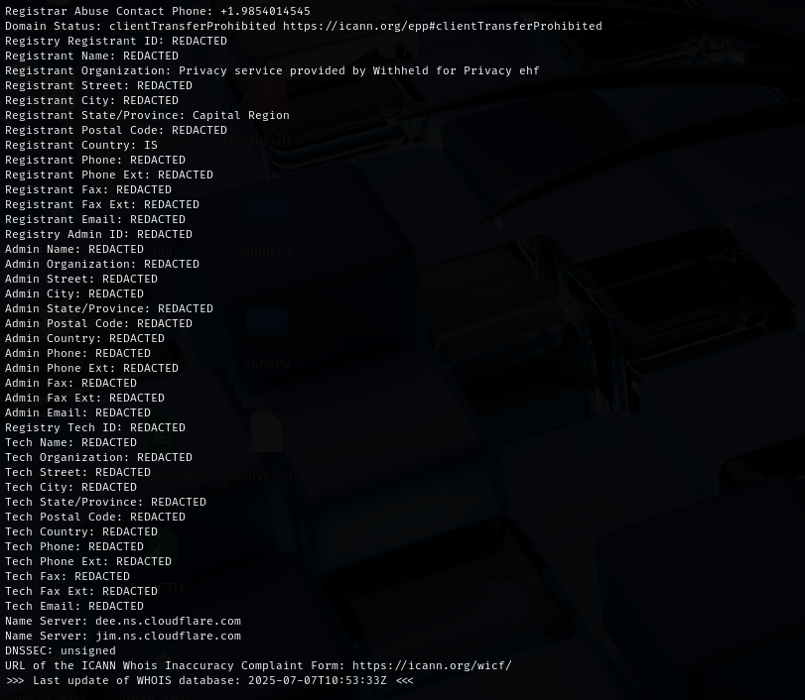
REDACTED.
It’s called WHOIS Privacy Protection (also known as domain privacy or WHOIS guard).
- When someone registers a domain, their name, email, address, and phone number would normally be publicly visible.
- But domain registrars (like Namecheap) offer a privacy service that hides this personal data to protect against:
  - Spam
  - Harassment
  - Doxxing
  - Cyberstalking

🧠 What is DNSSEC (in simple terms)?
DNSSEC adds digital signatures to DNS records to make sure:
- You're connecting to the real website
- The DNS information hasn't been tampered with (e.g., via DNS spoofing or poisoning)

The whois lookup give
Registrant (owner /buyer)
Registrar( dmain provider)
Admin (who handle domain )
Tech(who handle technical work of domain)
also give the name servers.

